**Database Design and Maintenance**

A Technical Report

on

**Online Music Store Database**

**Submitted By:**

Jaspreet Singh Kaberwal (8622568)

Miki Narayanbhai Patel (8622608)

Vishwa Wani (8622587)

|  |  |
| --- | --- |
| Content | Page No. |
| Acknowledgement | 3 |
| Abstract | 3 |
| Introduction | 3 |
| The EER mode of the database | 3 |
| Figure 1 | 4 |
| Description about Scenario | 4 |
| Solution for the Scenario | 5 |
| Conclusion | 5 |
| References | 5 |

**Index:**

**Acknowledgement:**

We take this opportunity to express our heartfelt gratitude to our Prof. Angelina Ziesemer for their comment on various aspects of this draft and thoughtful contribution to our efforts. Without their support and cooperation, we would not have completed this work.

We also thank our group members, for their help putting documents together. Under the guidance of our professor and with the help of our team members we were able to complete our project **“Online Music Store Database”** on time with success.

**Abstract:**

This report includes details about our online music store database like how we created an EER model, description of the scenario, how we generated queries regarding the scenario, time-tracker etc.

**Introduction:**

This database is for online music store to keep the records of the users’ details like playlists, account details, subscription details etc., songs, artists details, albums of the artists as well.

**The EER model of the database:**

* Enhanced Entity Relationship model (EER) is a tabular representation of the database.
* An EER is a data model for describing a database in an abstract way.
* This EER model contains eight tables as following:
* Customers:

It contains all the details about the users of the music store.

* Playlists:

It contains all the playlists of the customers.

* Songs:

It contains all songs which are available on music store.

* Albums:

This table contains all the albums of the artists.

* Genres:

This table contains genres of the all available songs.

* Artists:

It contains all the details about the artists.

* Address:

This tables contains details about the address of the customers.

* Payments:

This table contains payment details of the customers.

* Each table has a relationship with the other tables like one-to-one, one-to-many, many-to-many. It is shown in the figure 1.

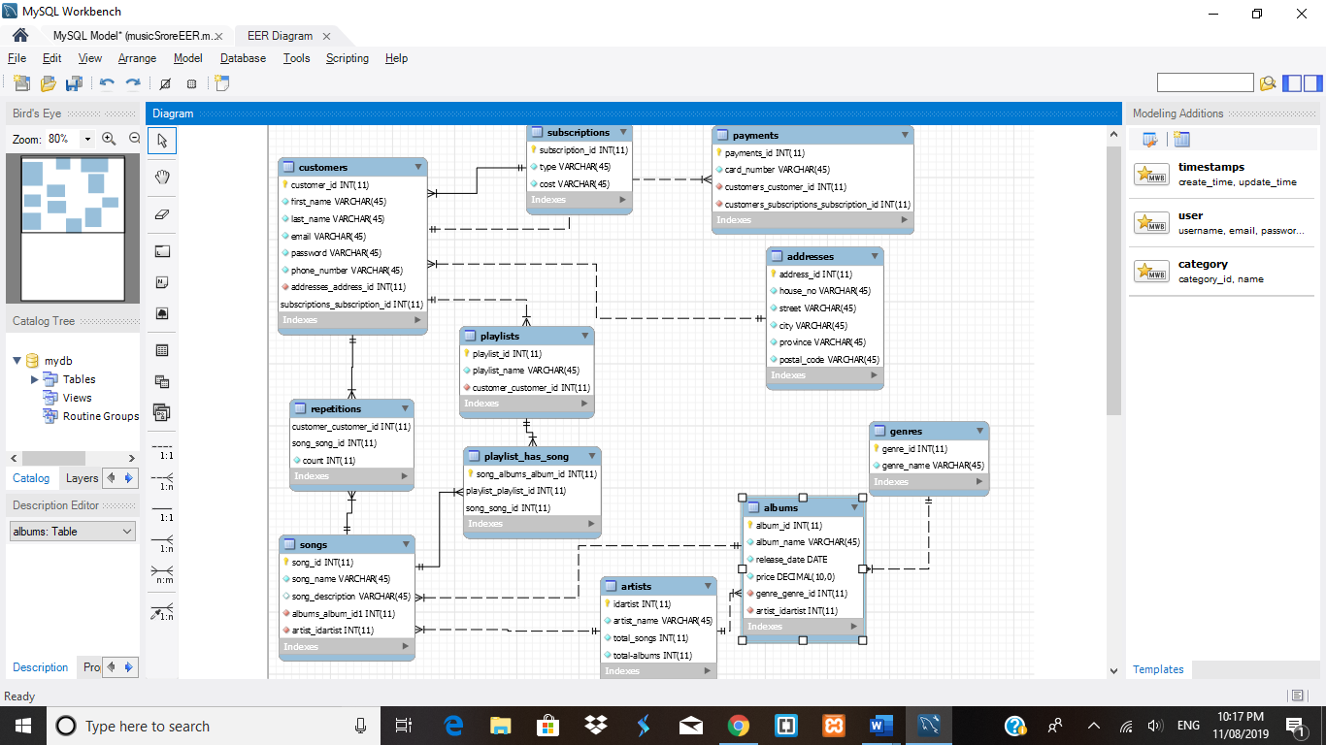

Figure -1

**Description about Scenario:**

* Our scenario is to design music playlist according to listing pattern/taste of each user.
* There are two questions arise as below:
* User listens to one singer frequently, the album has many songs, some songs are collaborative; i.e.; they have one or more singer. So how can we recommend individual songs of the other artist whom the user is not listening in particular but listen to collaborative songs.
* Create collaborative playlist for one or more users, fetching similar songs.

**Solution for the Scenario:**

* To justify these questions and scenario, we created views and procedures.
* We used songs, genres, albums tables for views and procedures.
* We define procedure to create views & for the questions we used that views in the procedure.

**Conclusion:**

The database has been designed to keep records of the users, songs, artists of the Online Music Store.

EER model is developed to define the relations between tables.

The system has been tested for several inputs to check the column definition, queries, scenarios and the questions.

**References:**

W3schools ([https://www.w3schools.com](https://www.w3schools.com/))

Murach’s MySQL: Training and Reference, 2nd Edition